**V2 DML**

**Question 1:**

**Sales department of the company wants to know about those products which have quantity orders more than 20. Write a inner query that retrieves product numbers, product names with the quantity, which is more than 20.**

*select P.product_code,P.product_name from products as P where p.id IN ( select O.product_id from order_details as O where O.quantity>20)*

**Question 2:**

**Write a co-related query that displays every customer name with total count of its order.**

*select C.first_name,(select count(O.id) from orders as O where C.id=O.customer_id ) as Total_Orders from Customers as C group by C.first_name*

**Question 3:**

**Write a co related query that display every product name with total quantity ordered of each product. (V2)**

[*select*](http://localhost/phpmyadmin/url.php?url=https://dev.mysql.com/doc/refman/5.5/en/select.html)*product_name, (*[*select*](http://localhost/phpmyadmin/url.php?url=https://dev.mysql.com/doc/refman/5.5/en/select.html)[*count*](http://localhost/phpmyadmin/url.php?url=https://dev.mysql.com/doc/refman/5.5/en/group-by-functions.html#function_count)*(quantity) from order_details where products.id = order_details.product_id) from products*

**Question 4:**

Display name of all customers with their respective total order count whose payment_type is ‘Cash’. Don’t display customer if its total order count is zero. **[Use Co-related sub query. No Join/cross product is allowed].**

*SELECT CONCAT(first_name, ' ', last_name) AS Customer_Name,*

*(SELECT COUNT(orders.customer_id) FROM orders*

*WHERE customers.id = orders.customer_id AND orders.payment_type = 'Cash') AS Order_Count*

*FROM customers GROUP BY customers.id HAVING Order_Count <> 0;*

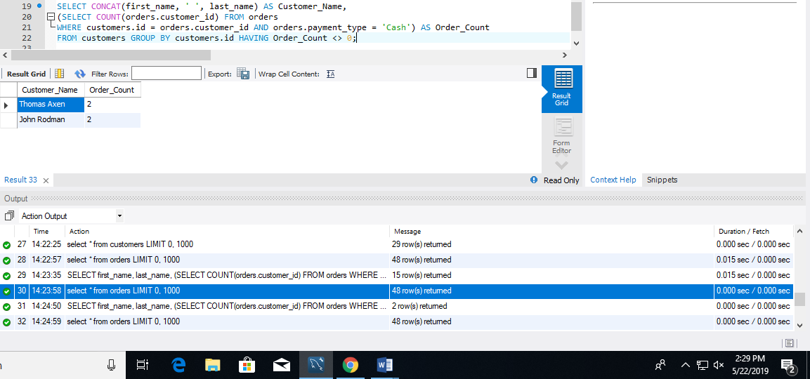

**Question 5:**

Display Name of those employees who has privileges of ‘Purchase Approvals’ and lives in city ‘Redmond’ or ‘Bellevue’ or ‘Kirkland’. **[Use Nested query. No Join / cross product / Co-related sub query is allowed]**

*SELECT CONCAT(first_name, ' ', last_name) AS EmployeeName, city*

*FROM employees WHERE city IN('Redmond', 'Bellevue', 'Kirkland') AND*

*id IN (SELECT employee_id FROM employee_privileges WHERE privilege_id IN*

*(SELECT id FROM privileges WHERE privilege_name = 'Purchase Approvals'));*

